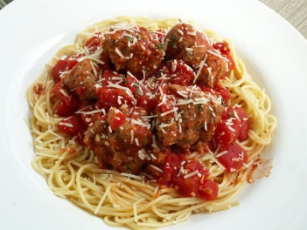
Spaghetti Dinner and 50/50 Raffle

Saturday, September 16, 2017 from 5 p.m. to 7 p.m.
at the Arthur Colby Safety Building on 8 Cooper Street
Parking is located off South Village Road and Recreation Drive

Sponsored by: Loudon Communications Council
Publisher of The Loudon Ledger

Admission: $10.00 Adult
$ 8.00 Seniors/Military
$ 6.00 Children 10 & under

Please join us for an All-You-Can Eat Spaghetti dinner, which includes salad, garlic bread, spaghetti, dessert, and beverage.

We would like to thank Brookside Pizza and Loudon Mart for donating the food, beverages, and paper products.

